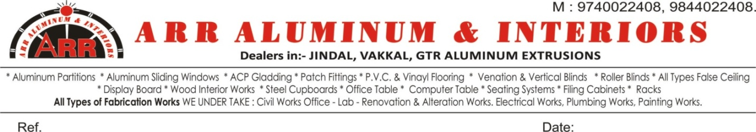

QTN/80/ARRAI/2020 Date: 02/12/2020

TO:-

DR. PRABHAKAR REDDY

PAVAN COLLEGE

KOLAR

**Sub:- Quotation For aluminium partitions and Siding wondows**

We Are Pleased To Furnish Our Most Competitive And Lowest Quotation For Your Requirements.

|  |  |  |
| --- | --- | --- |
| **SL.**  **No.** | **DESCRIPTIONS** | **AMOUNT** |
| 01 | Towards Supplying and Fabricating of Aluminium Partition using **Jindal Company Material** 2 ½ x 1 ½ box Section With 4mm glass and two track sliding windows using two track bottom Side and one side open both side open and inter lock section with 4mm plain or cooling glass with all accessories Approximate size 150x7½ x175/-(Measurement take after finishing work) 1125Square feet (Approximate) | **Rs. 1,96,875/-** |
| 02 | Towards Supplying and Fabricating of Aluminium Partition using **Non Jindal (Local Material)** 2 ½ x 1 ½ box Section With 4mm glass and two track sliding windows using two track bottom Side and one side open both side open and inter lock section with 4mm plain or cooling glass with all accessories Approximate size 150x7½ x160/-(Measurement take after finishing work) 1125Square feet (Approximate) | **Rs. 1,80,000/-** |
| 03 | Labour per quare feet | **RS. 40/-** |



QTN/80/ARRAI/2020 Date: 02/12/2020

**--------2------**

**TERMS AND CONDITIONS:-**

1. Payment: 50% Advance against confirmation of order (Along with P.O),40% Finishing of frame work, balance finishing of work
2. G.S.T @ 18% EXTRA
3. Work Finish within 10 days from wrok start
4. Purchase Order should be in the name of M/s. ARR ALUMINIUM & INTERIIOS
5. Cheque/DD should be in the name of M/s ARR ALUMINIUM & INTERIIOS

Thanking you and assuring you of our best services and co-operation and prompt services at all times.

Yours truly,

**For ARR ALUMINIUM & INTERIIOS**

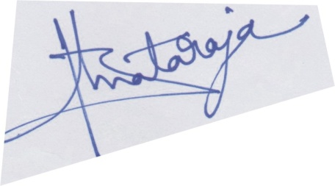

Proprietor.

**9844022408 / 9740022408**